**The story of cork**

**Exercise 2.**

1. Read the texto below and answer:

1. Where does cork come from?

2. What is the most important product made from cork?

3. Which country is the world’s biggest producer of cork?

4. Why does NASA use cork in ocket engines?

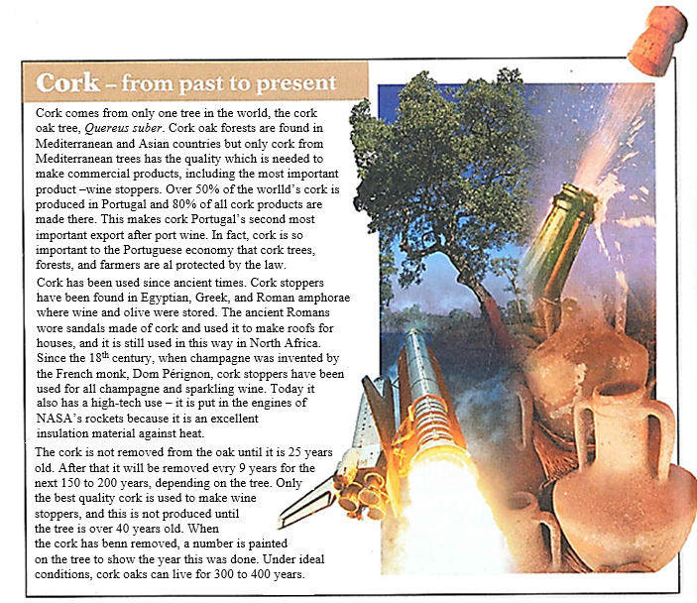2. Underline all the examples of verbs in the passive voice and identify their tenses: *Present Simple, Past Simple, Present Perfect, Future*

**The passive voice\***

|  |  |
| --- | --- |
| **Present Simple**   * Cork oak forests **are found** in Mediterranean and Asian countries. * The cork **is not removed** from the oak until it is 25 years old. | Facts, habits. |
| **Past Simple**   * Champagne **was invented** by the French monk, Dom Pérignon. * Wine and olive oil **were stored** in Egyptian, Greek, and Roman amphorae. | Finished actions in the past, with definite time (no necesariamente una fecha). No se sabe la fecha exacta pero se sabe que son acciones terminadas. |
| **Present Perfect**   * Cork **has been used** since ancient times. * Cork stoppers **have been found** in Egyptian, Greek, and Roman amphorae. | Past actions that continue to the present.  Past actions with no definite time.  (Only time expressions with **“since”** and **“for”** can be used. |
| **Future**   * The cork **will be removed** every 9 years for the next 150 to 200 years. | Future actions |

**\* *The Passive Voice*** is used when the action is important (not the person carrying it out) or when the person is unknown.

The verb **“to be”** determines the tense (present, past, present perfect, future, etc.)

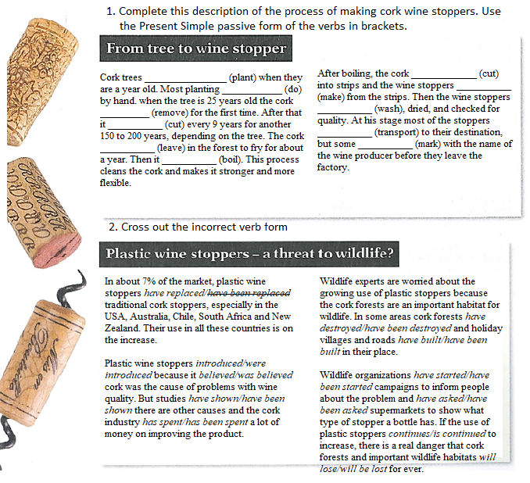**Exercise 3.**

Are planted is cut

is done are made

is removed are washed

is cut

are transported

is left are marked

is boiled

----------------------------

--------------

-------

-------

---------------- ------------------- ------------------

---------------- ----------------

-------------

-------------

----------------

**Exercise 4.**

1. Complete the following list of facts about coffee using the correct tense in the passive voice.

**Are consumed**

**Are used**

**Was opened**

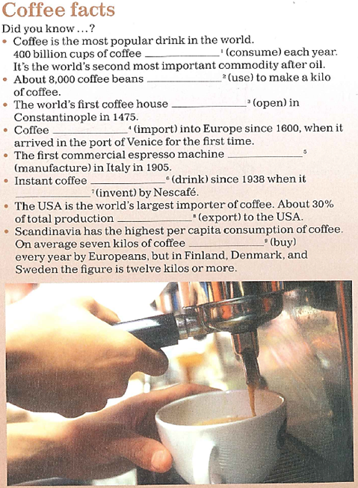

**Has been imported**

**Was manufactured**

**Has veen drunk**

**Was invented**

**Is exported**

**are bought**

**Describing a process**

**Exercise 5.**

Click [***here***](https://drive.google.com/file/d/1QBkg5N56-UDoM6TQd6tnrnAj5xg2hVP3/view?usp=sharing)to listen 10.7.

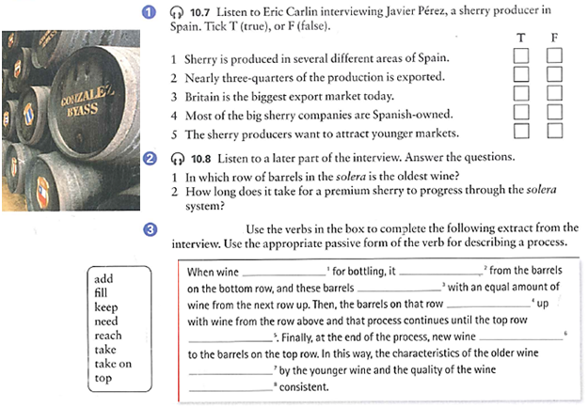Click [***here***](https://drive.google.com/file/d/1XAdFip5U4l-moc8kKkJhaHjqYC2qPDE3/view?usp=sharing) to listen 10.8.

**Exercise 6.**

Number the stages below to show the correct order in which olive oil is made. Then write the sentences in the passive.

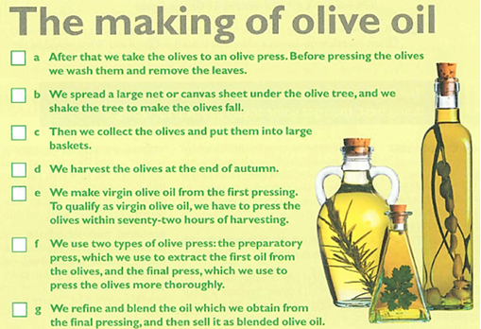

4

2

3

1

6

5

7

1. The olives were harvested at the end of autumn.
2. A large net or canvas sheet is spread under the olive tree, and it is shaken to make the olives fall.
3. Then the olives are collected and they are put into large baskets.
4. After that the olives are taken to an olive press. Before pressing the olives, they are washed and their leaves are removed.
5. Two typed of olive press are used: the preparatory press, which is used to extract the first oil from the olives, and the final press, which is used to press the olives more thoroughly.
6. Virgin olive is made from the first pressing. To qualify as virgin olive oil, the olives are pressed within seventy-two hours of harvesting.
7. Oil that is obtained from the final pressing is blended and refined, and then it is sold as blended olive oil.

**Tarea:** pasar a pasive voice las etapas de produccion del aceite de oliva